Batch: B2 Roll No.: 16010121200

Experiment No. 6

Grade: AA / AB / BB / BC / CC / CD /DD

Signature of the Staff In-charge with date

TITLE: Implementation of dining philosopher problem using threads.
_____________________________________________________________________

AIM: Implementation of Process synchronization algorithms using threads – Dining Philosopher problem
______________________________________________________________________
Expected Outcome of Experiment:

CO 2. To understand the concept of process, thread and resource management.
CO 3. To understand the concepts of process synchronization and deadlock.
_____________________________________________________________________
Books/ Journals/ Websites referred:

- Silberschatz A., Galvin P., Gagne G. “Operating Systems Principles”, Willey Eight edition.
- Achyut S. Godbole , Atul Kahate “Operating Systems” McGraw Hill Third
Edition.
- William Stallings, “Operating System Internal & Design Principles”, Pearson.
- Andrew S. Tanenbaum, “Modern Operating System”, Prentice Hall.
_____________________________________________________________________
Pre Lab/ Prior Concepts:

Knowledge of Concurrency, Mutual Exclusion, Synchronization, Deadlock, Starvation, threads.
_____________________________________________________________________

Description of the chosen process synchronization algorithm:
The solution to the Dining Philosophers problem using a monitor involves following key elements:
- Shared Resources: Philosophers share a set of forks placed on the dining table. These forks are the shared resources that need to be managed to avoid conflicts.
- Monitor: A monitor is a high-level synchronization construct that encapsulates the shared resources and the operations that can be performed on them. It ensures that only one philosopher can access a fork at a time.
- Condition Variables: The monitor uses condition variables to control access to the forks. Each fork is associated with a condition variable, and philosophers wait on these condition variables when they want to pick up a fork.
- Rules for Picking Forks: Philosophers follow certain rules, typically involving taking forks in a specific order (e.g., left fork first and then right fork) to prevent deadlock situations.
- Synchronization: The monitor ensures that only one philosopher at a time can access a fork, and when a philosopher can't pick up both forks, they release any forks they hold and wait for the necessary conditions to be met before trying again.
The use of a monitor simplifies the synchronization and coordination of the philosopher’s actions, preventing race conditions, and ensuring that each philosopher can eat without conflicts. This solution ensures that the Dining Philosophers problem is solved safely and efficiently in a multithreaded or concurrent environment.

Implementation details: (printout of code)
import threading
import time

class DiningPhilosophers:
def __init__(self, n_philosophers):
self.n_philosophers = n_philosophers
self.forks = [threading.Condition() for _ in range(n_philosophers)]

def pick_forks(self, philosopher_id):
left_fork = philosopher_id
right_fork = (philosopher_id + 1) % self.n_philosophers

with self.forks[left_fork]:
with self.forks[right_fork]:
print(f"Philosopher {philosopher_id} is eating. ")
time.sleep(1)

def dine(self, philosopher_id):
for _ in range(3):
print(f"Philosopher {philosopher_id} is thinking. ")
time.sleep(1)
print(f"Philosopher {philosopher_id} is hungry. ")
self.pick_forks(philosopher_id)
print(f"Philosopher {philosopher_id} is done.")

if __name__ == '__main__':
n = int(input("Enter number of philosophers: "))
philosophers = []

dining_table = DiningPhilosophers(n)

for i in range(n):
philosopher = threading.Thread(target = dining_table.dine, args=(i,))
philosophers.append(philosopher)
philosopher.start()

for philosopher in philosophers:
philosopher.join()

print("Dining complete.")

Output:
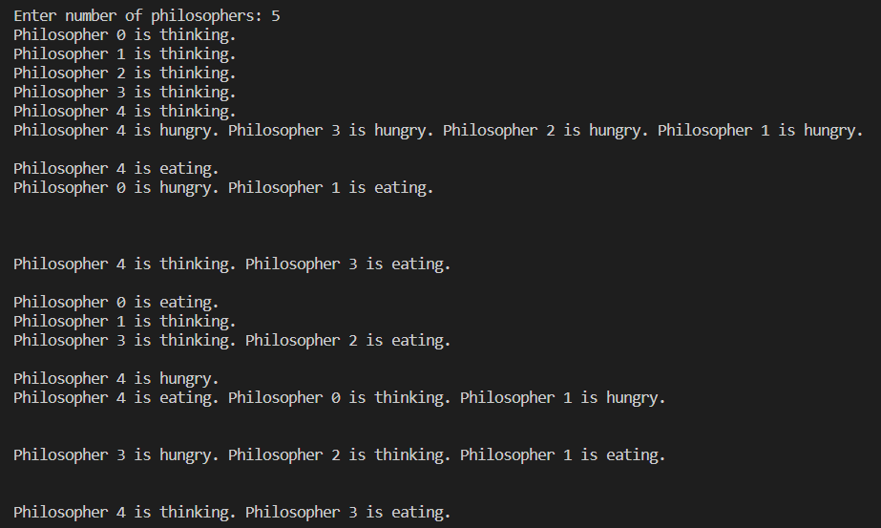
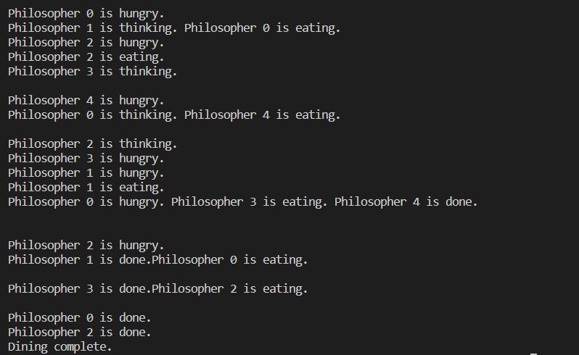

Conclusion:
Understood and successfully implemented the dining philosophers’ problem.
Understood the concepts of process synchronization, deadlocks and resource management.
Post Lab Descriptive Questions

      - Differentiate between a monitor, semaphore, and a binary semaphore?
A monitor is a high-level synchronization technique that enables threads to mutual exclusion and the wait() for a given condition to become true. It is an abstract data type. It has a shared variable and a collection of procedures executing on the shared variable. A process may not directly access the shared data variables, and procedures are required to allow several processes to access the shared data variables simultaneously.
At any given time, only one process may be active in a monitor. Other processes that require access to the shared variables must queue and are only granted access after the previous process releases the shared variables.
A semaphore is a low-level synchronization technique that allows threads to coordinate and control access to shared resources. It consists of a non-negative integer and provides two main operations: "wait" (P) and "signal" (V). Threads can decrement the semaphore value when they want to access a resource (P), and increment it when they are done (V). Semaphores can be used for various synchronization tasks but require careful management to avoid issues like deadlock and contention.
A binary semaphore is a specific type of semaphore with a value of either 0 or 1. It is often used as a simple mutex or lock to provide mutual exclusion, allowing only one thread to access a critical section of code at a time. They are particularly useful for scenarios where exclusive access is needed, and they are simpler to use than general semaphores with higher integer values.
      - Define clearly the dining-philosophers problem?

In the Dining Philosophers Problem, there are a certain number of philosophers sitting at a round dining table, and each philosopher alternates between thinking and eating. To eat, a philosopher needs two forks, one on their left and one on their right. The challenge is to design a solution that ensures that each philosopher can eat without leading to deadlock (where all philosophers are waiting for a fork and none can make progress) or contention (where multiple philosophers try to grab the same fork simultaneously).

      - Identify the scenarios in the dining-philosophers problem that leads to the deadlock situations?

A scenario when all the philosophers pick up the left chopstick and then have to wait for the right one will create a deadlock situation.

Date: 3/11/2023 Signature of faculty in-charge

